Tirumala Reddy Konireddy

Lab 04 report

Training Testing Motion Capture data using web service

**Data Collection from BLE sensor Tag and Android Mobile device**

I had imported our tutorial program App1 –App3 GPS into our local Eclipse, which is able to write data about Accelerometer service from BLE sensor tag, present Date and GPS location of Android Mobile device. I had understood the code and methods related to enabling, reading and notifying different sensors of BLE sensor tag. I had developed that code to write Humidity, Temperature, Gyroscope and Pressure values of room using sensor tag services.

Please find my source files in my github :

https://github.com/tkhgf/Big-data-labs/tree/master/lab%2003

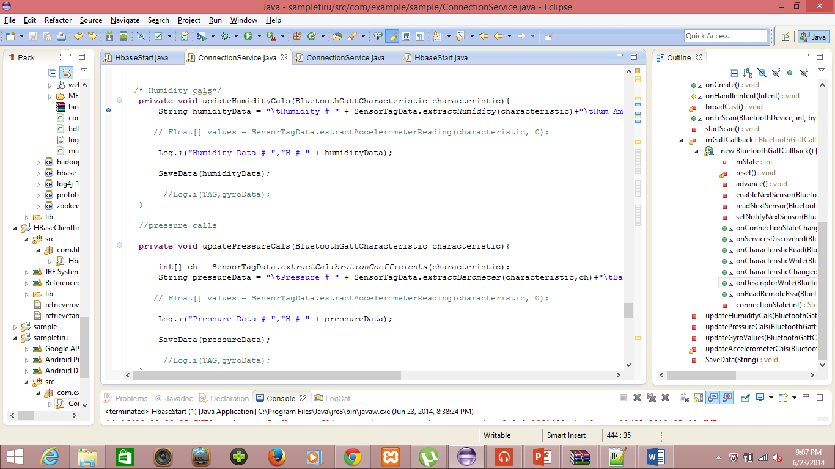

I had found the accelerometer, GPS , Humidity sensor enabling while running application in Android device as below.

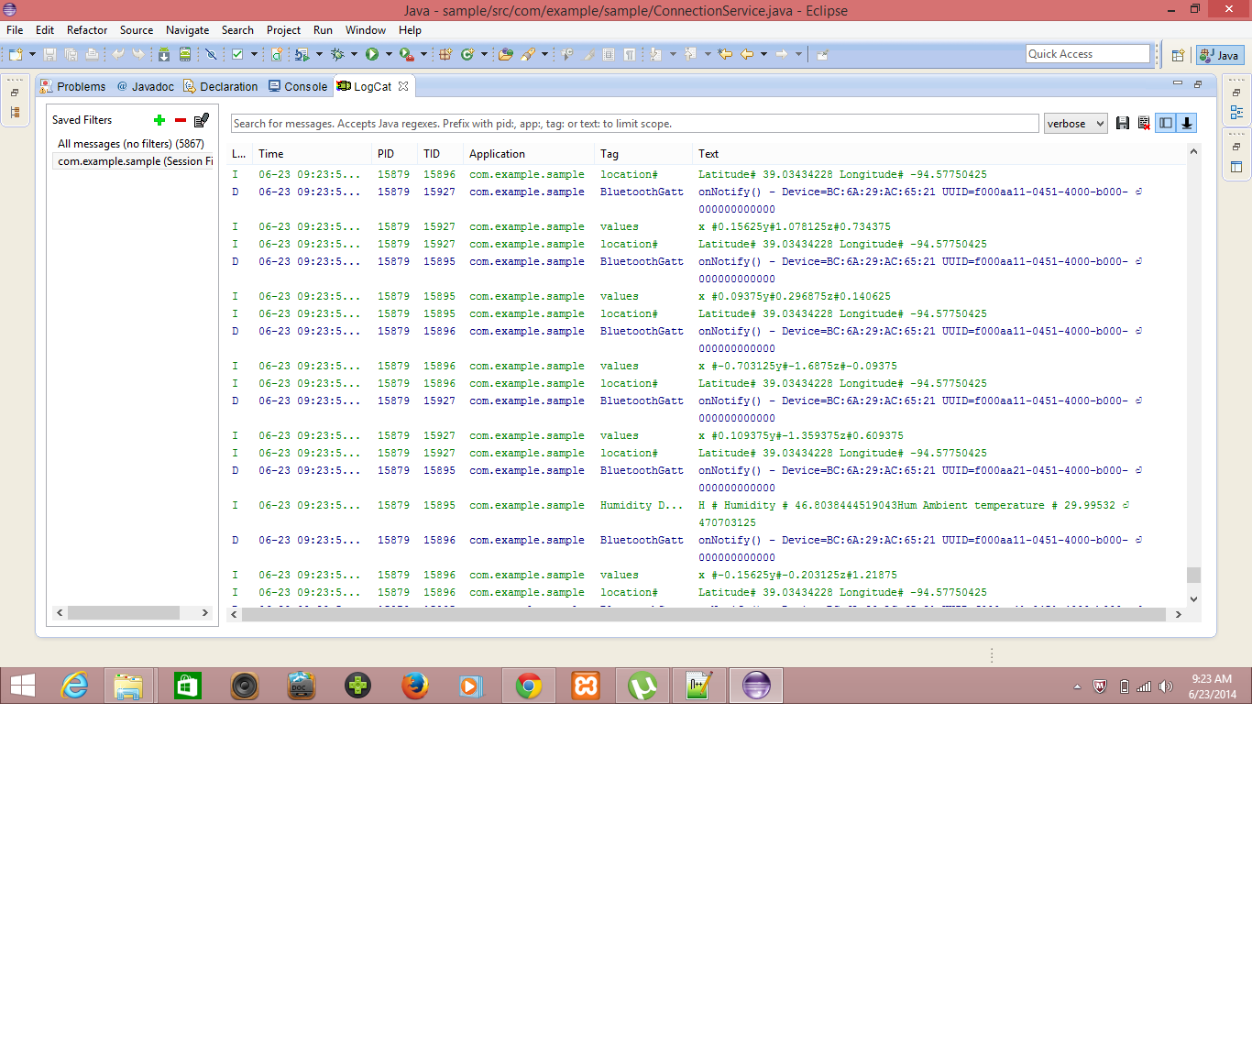

I had successfully written the Humidity and Temperature data along with the old data services as below.

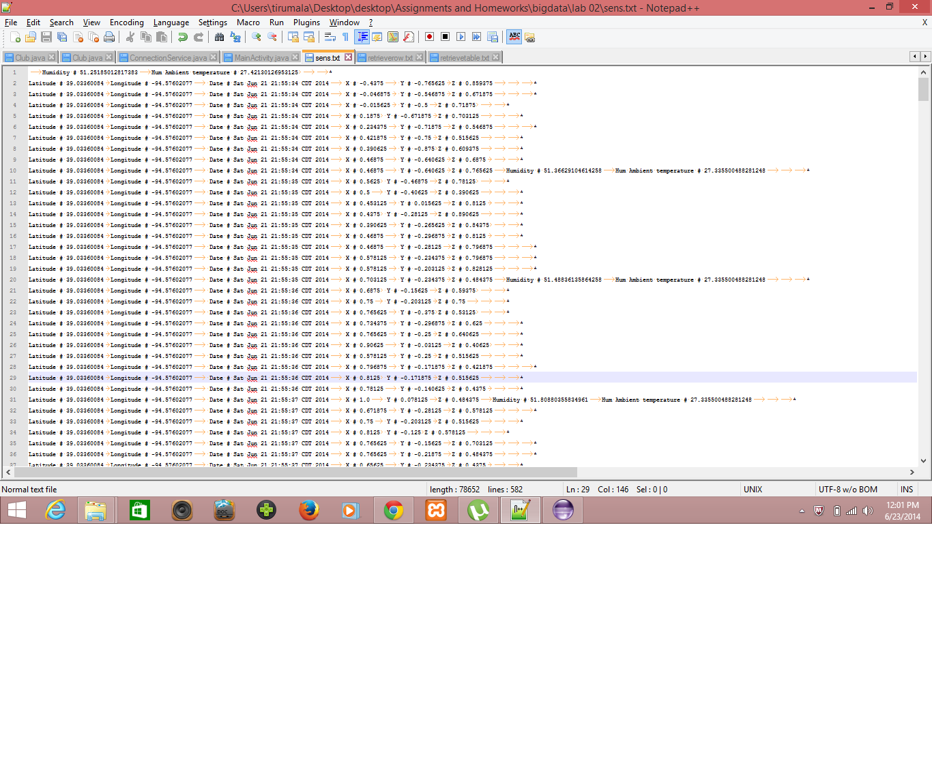

**Uploading Data to HBase using Web service**

I had developed a web service to upload all this data into HBASE server for using this data to train gestures as follows,

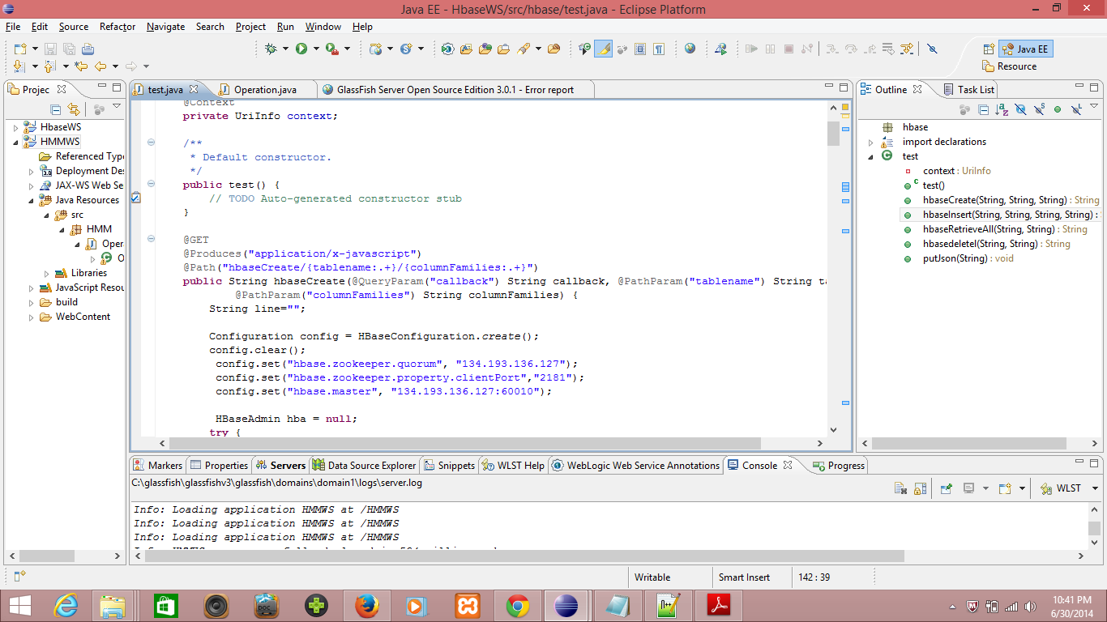

I had created a table in HBASE with my name TirumalaLab3Table,

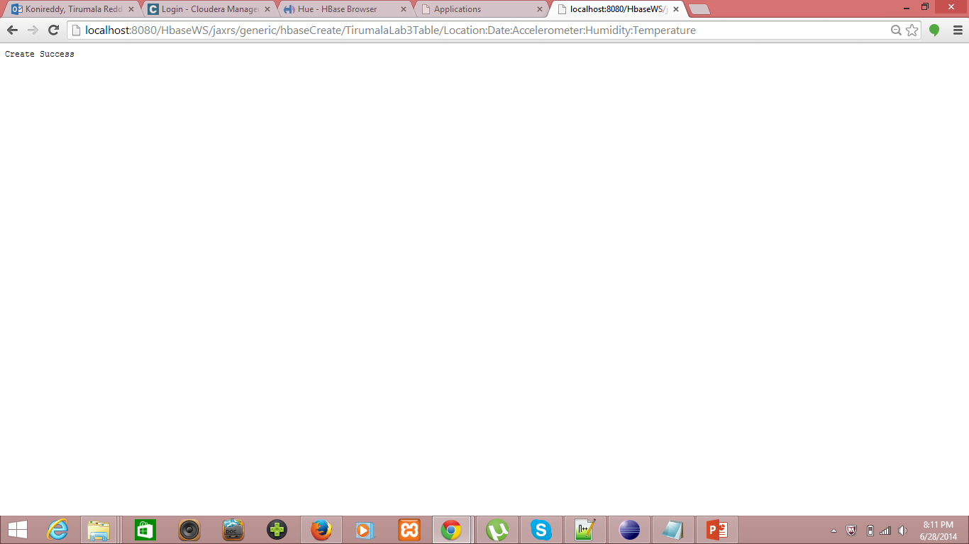

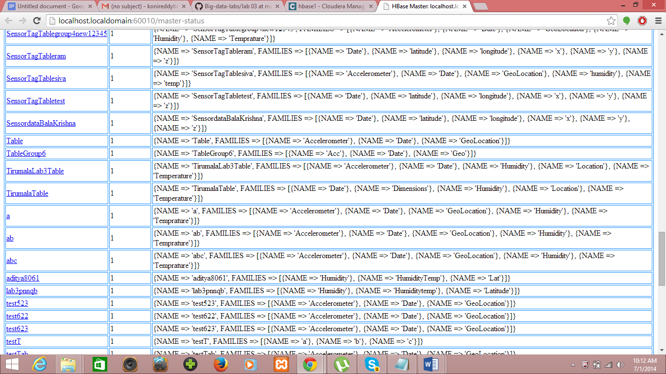

I had inserted the sensor data into the text file as follows, using webservice

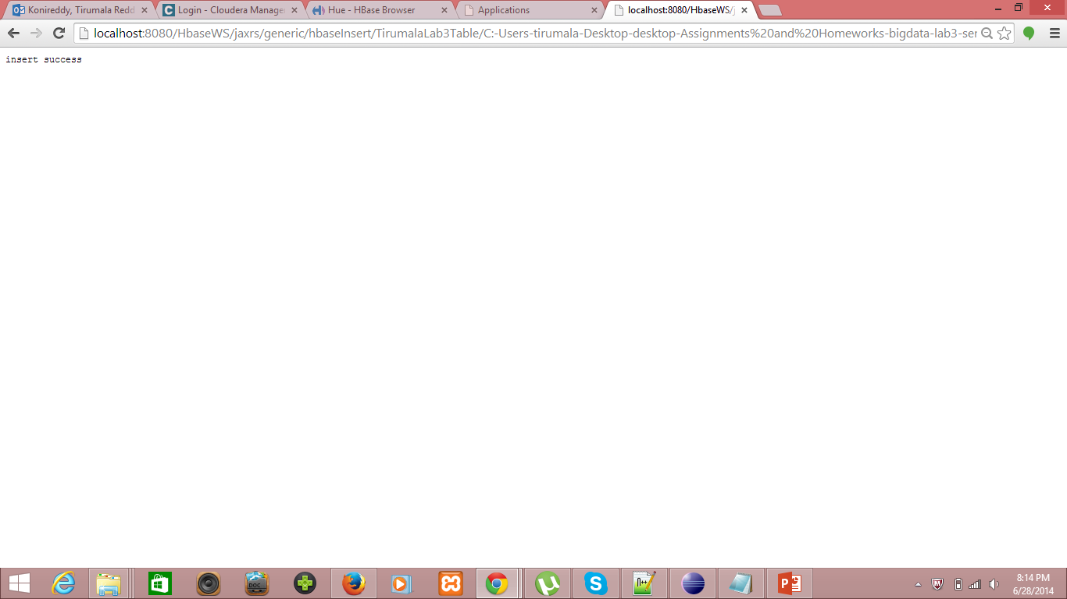

The data uploaded to Hbase can be viewed Hbase browser as follows,

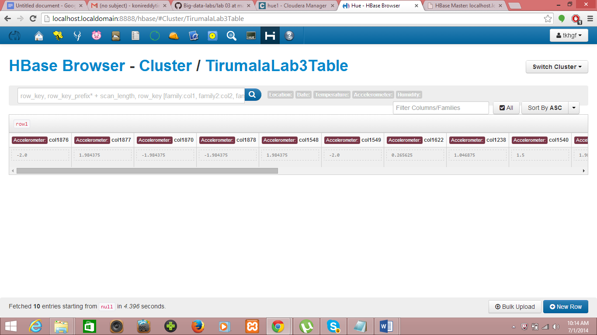

I had successfully accessed data stored in Hbase on retrieval,

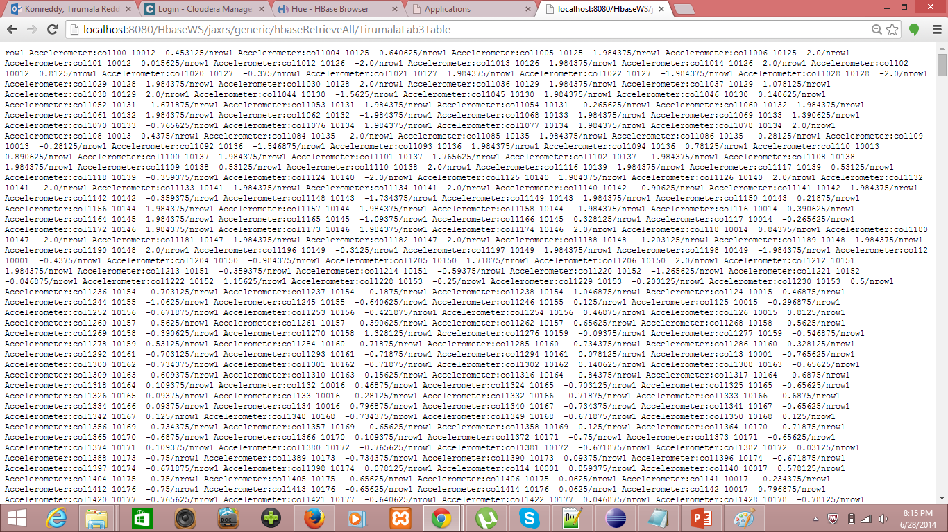

**Training and Testing Motion Capture data:**

We had used the following webservice HMMWS webservice to convert the input Motion Capture text data values of X, Y, Z dimensional tab separated data file.

We need to first eliminate or remove the noise in motion capture data by caluculating the distance or root mean square value of the motion capture data as D = sqrt(x^2 + y^2 + z^2). Using this we had created a sequential file after removing the noise.

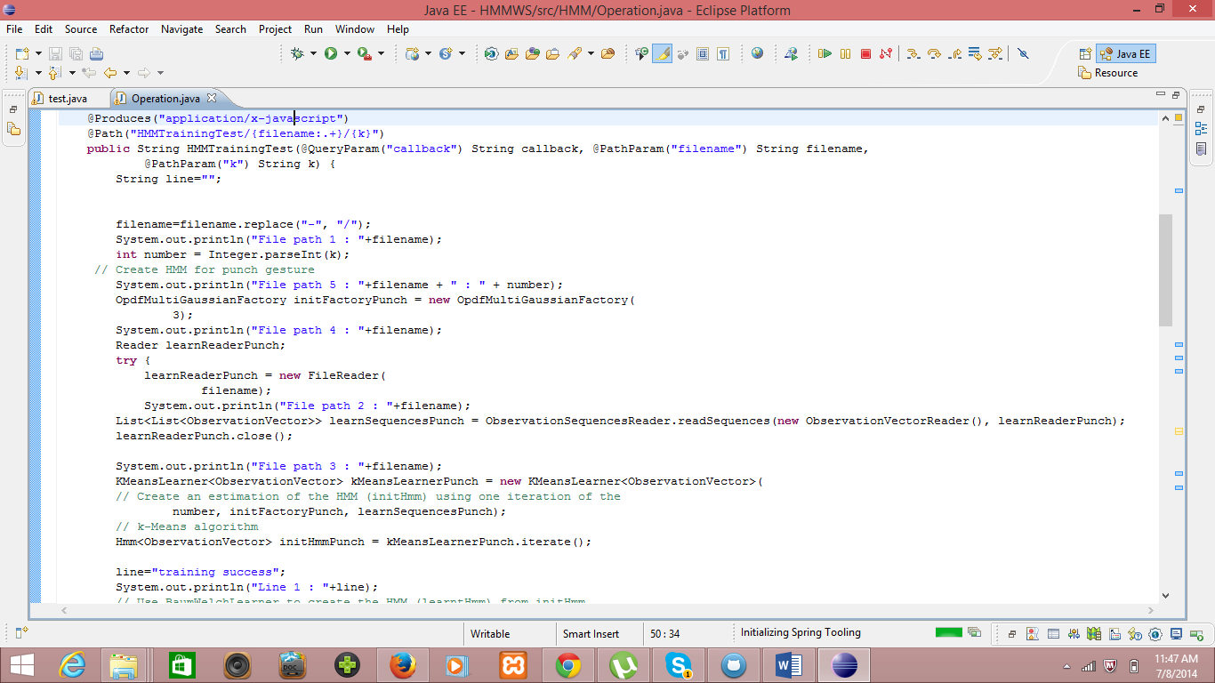

**Acceleration Data Collected for specific actions:**

I had done this work for both the Lab 04 and our project. So, I had trained different actions like feeling hungry, thirsty and Wish to play game.

I used three gestures : 1. Double Pat on stomach for hungry intent.

2. Lift the thumb upto mouth for thirsty intent.

3. Circle motion thrice in air for play game intent.

Here, we are using combination of accelerometer sensor data for training and testing of actions performed using BLE sensor tag.

We had collected data for to intent three Alert services namely Hungry, Thirsty and Play game.

**Data Collected for Hungry:**

We used “Pat on Stomach” for two times to intent Hungry alert for the respective care taker.

The sensor data collected for this action is as below.

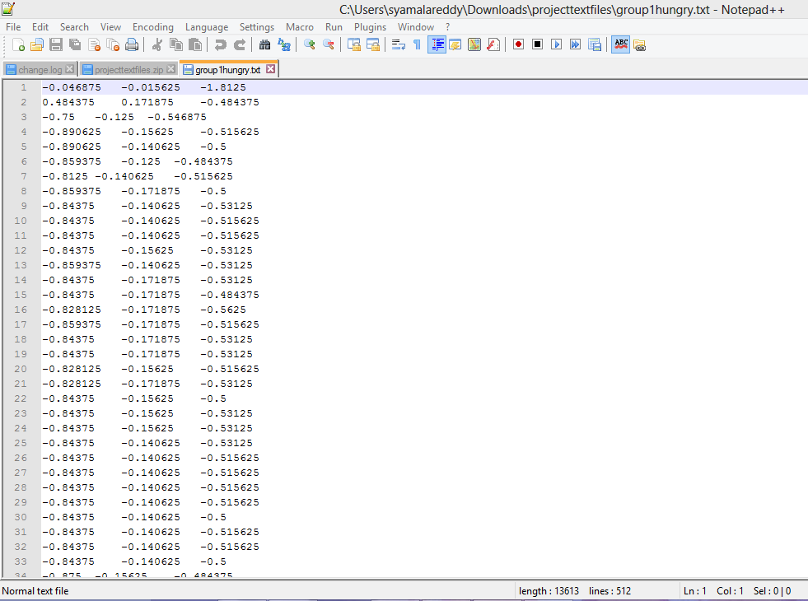

**Sensor Data Text file collected for Hungry gesture**

**Data Collected for Thirsty:**

We used “lifting hand from normal position upto mouth and return to normal position” to intent Thirsty alert for the respective care taker.

The sensor data collected for this action is as below.

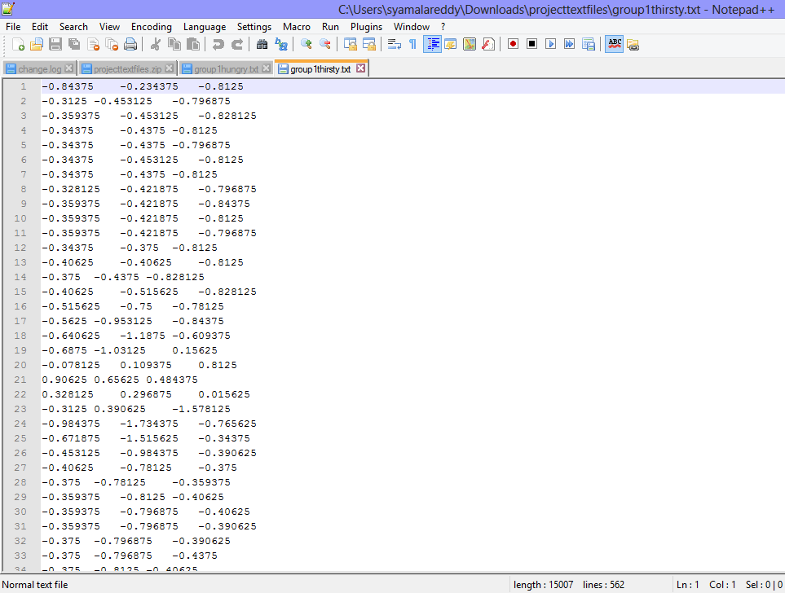

**Sensor Data Text file collected for Thirsty gesture**

**Data Collected for Playing game:**

We used “Draw three circles in air” to intent Play Game Activity in our application.

The sensor data collected for this action is as below.

We used a web-service to convert this text data into sequential files to filter the noise in the data and extract the data related to gestures.

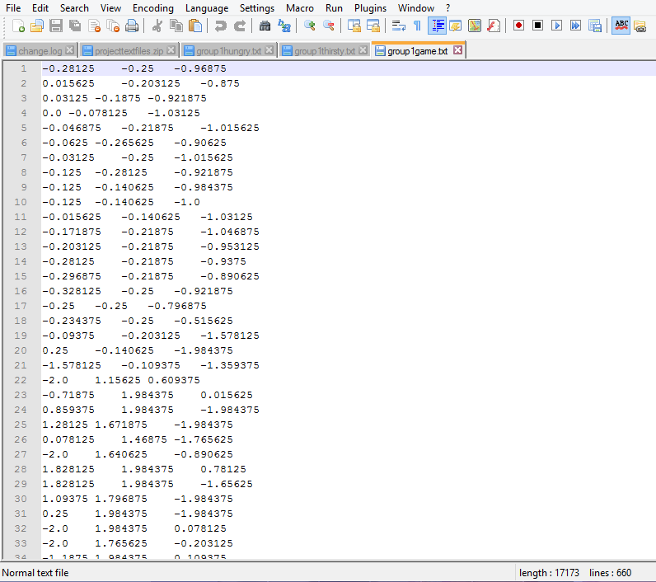

**Sensor Data Text file collected for playing game**

**Sequence file generation for Hungry:**

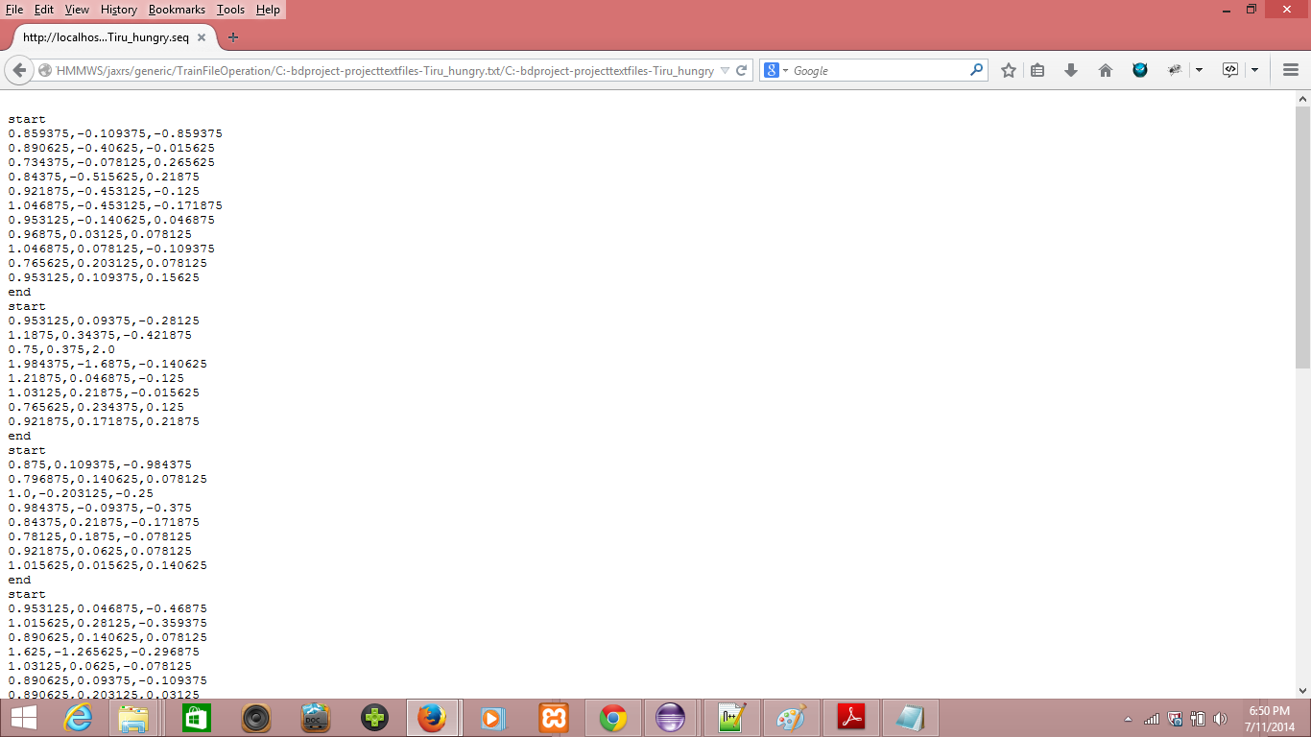

**Sequence file generated for the action hungry**

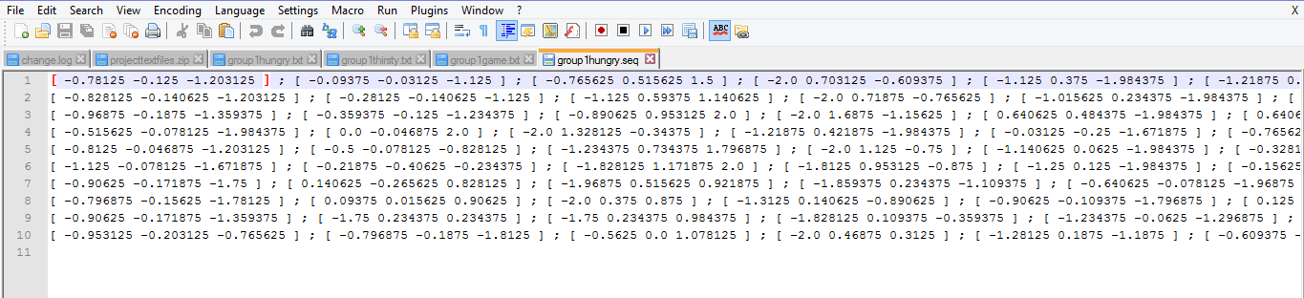

**Sequence file generation for Thirsty:**

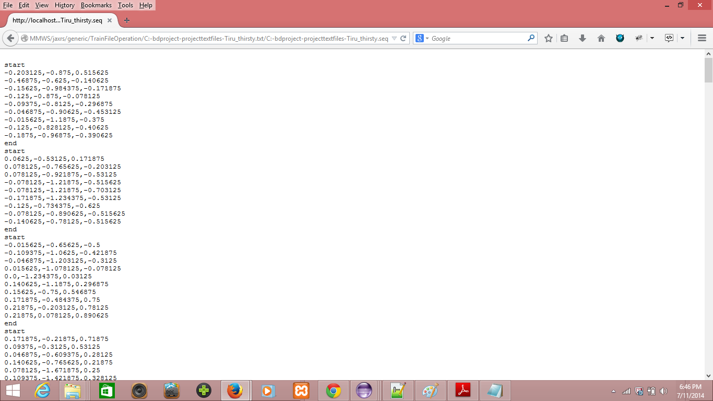

**Sequence file generated for the action thirsty**

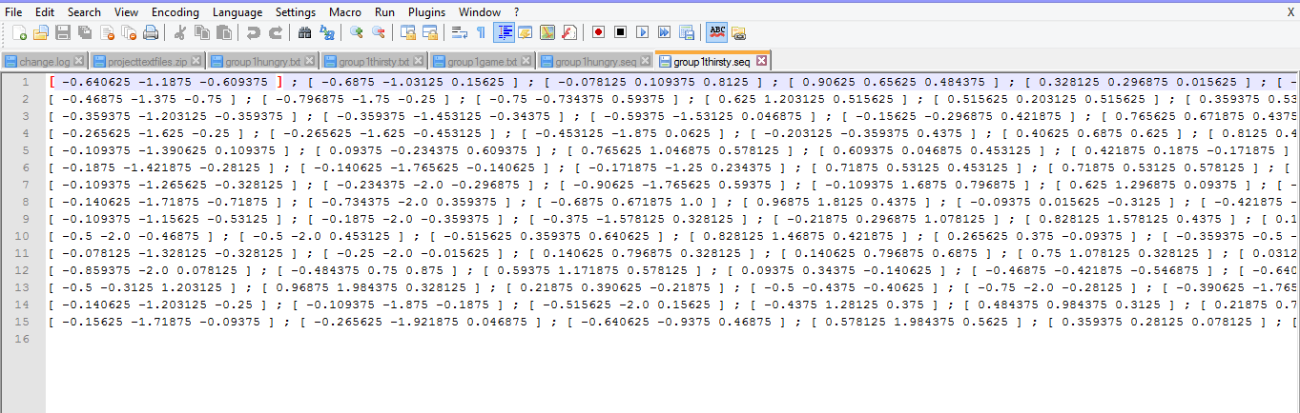

**Data Filtering and Machine Learning:**

**Sequence file generation for Playing Game:**

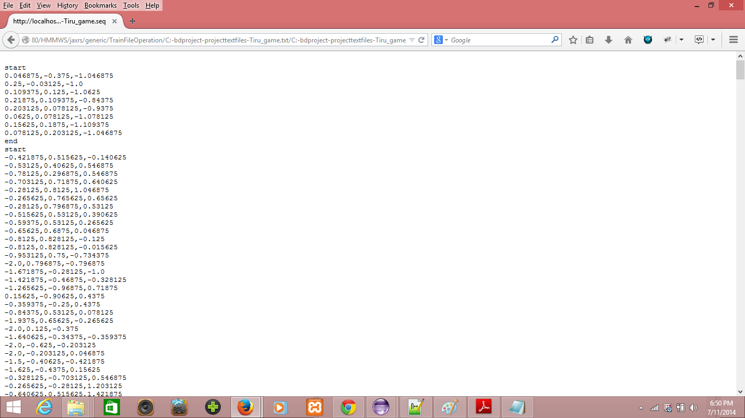

**Sequence file generated for the playing game**

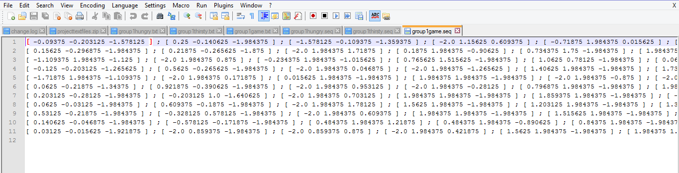

**Training and testing of Gesture data:**

We used a web service for training and testing of gestures. Here we need to generate the sequence files for all the training gestures individually and combination of all training gestures in testing gesture.

Sequence files generated for test data as below:

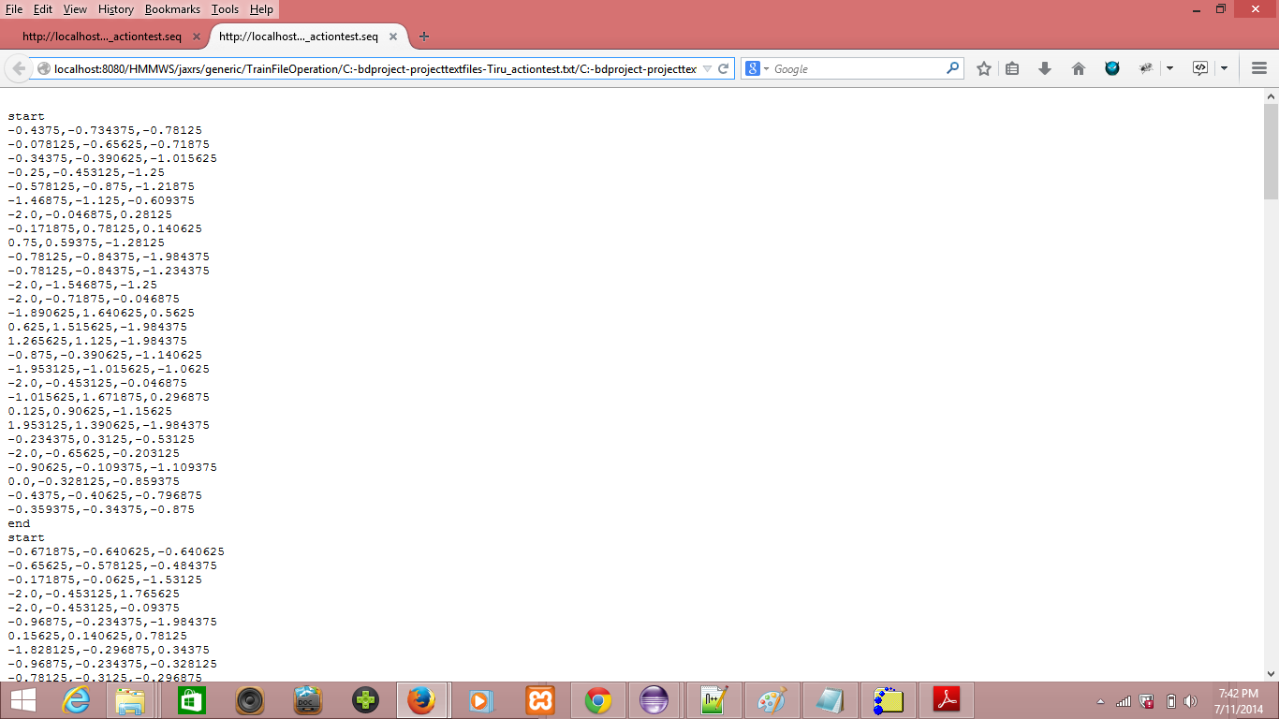

**Sequence file which is generated for the test data**

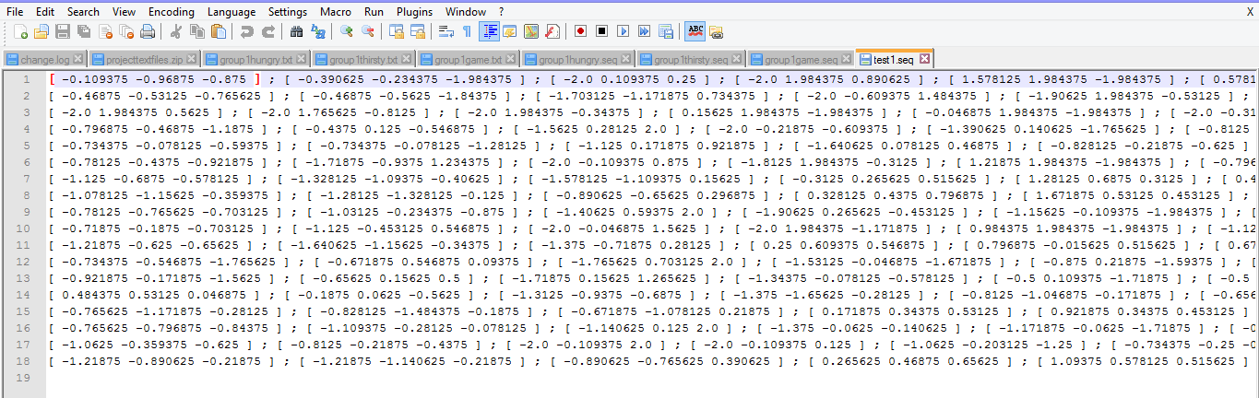

**Sequence file generated with the testdata1**

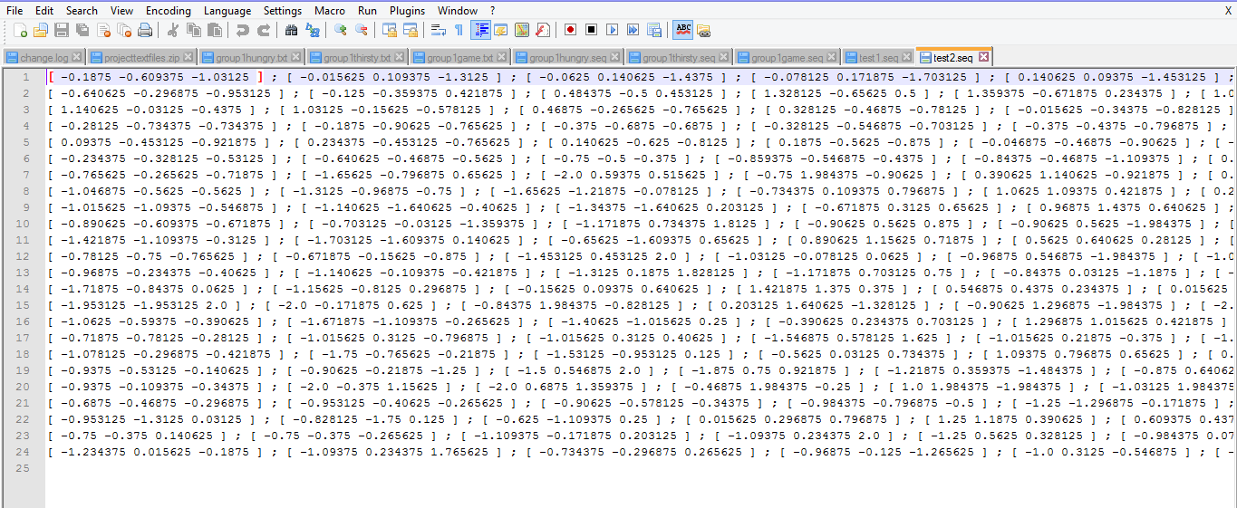

**Sequence file generated for the testfile2**

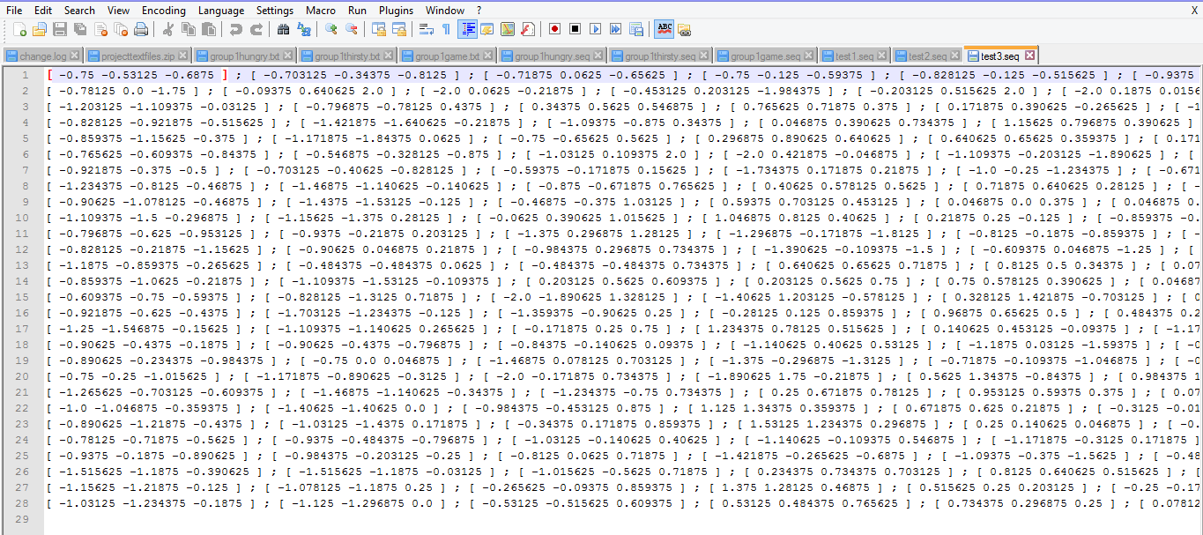

**Sequence file generated for the testfile3**

**Evaluation Model:**

**Testing of gestures using training sequence files:**

We are using training and testing sequence files for classifing a gesture into a particular.